**Lesson 1**

Our thinking guides our beliefs & actions

Good thinking Widely Agreed upon Criteria

1. Clarity, in understanding the problem.

Elaborate further? Illustrate what you mean? Identify the consequences of various options

1. Logic & reason, in proposing solutions

How does one point lead to another? Does this all make sense together?

Apply Logic and offer reason

1. Evidence to justify the solution

What do you use to support your claims? Is it credible? Ensure that the source is credible.

1. Open-minded in considering other proposals

Are you able to suspend your judgment and consider other views?

Try exploring other alternative solutions. Re-examine his views.

Critical thinking can improve our decision-making ability

Factors that affect our thinking and decision-making

1. Emotions
2. Assumptions
3. Personal Experiences
4. Beliefs & Values
5. New Information

**Lesson 2**

Claim – A statement someone asserts to be true.

Examples of Claims

1. I have three brothers.
2. Jane is a good person.
3. To lose weight fast, eat less white rice.

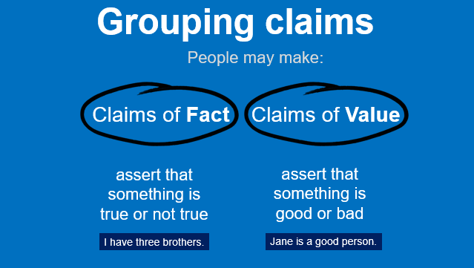

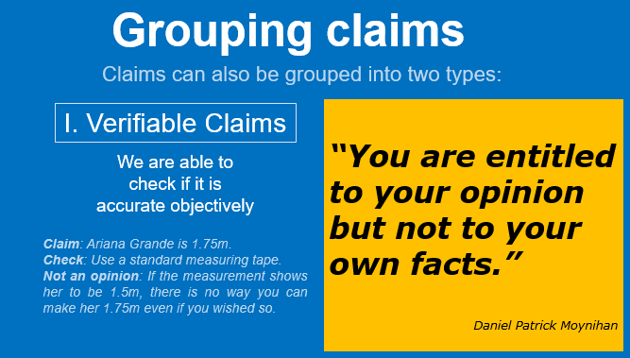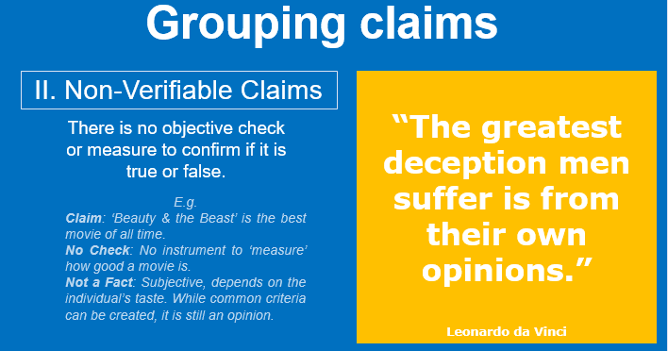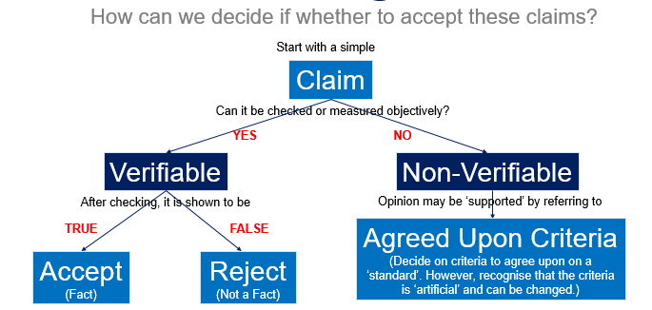

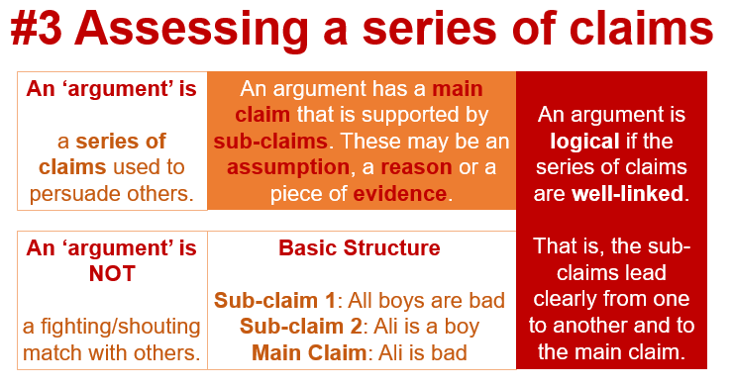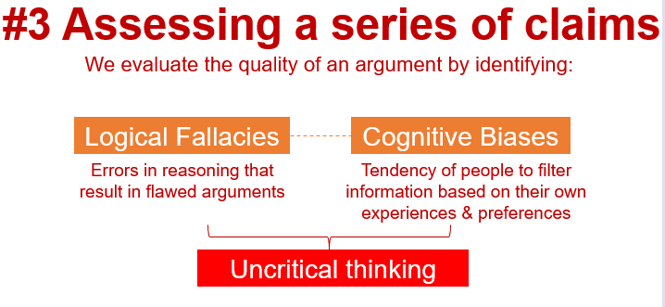

Logical Fallacies

Bandwagon Fallacy - If everyone is doing this, then it must be a good thing

Appeal to Improper Authority - All designers are more informed when it comes to branded products

Slippery Slope - THE LINKS BETWEEN EACH OF THESE SUB-CLAIMS ARE NOT STRONG

*Cite Sub-claims and draw a conclusion*

Cognitive Biases

Anchoring Biases - Tendency to rely on the first piece of information (the anchor) to make decisions.

Loss Aversion - Tendency to prefer avoiding losses to acquiring gains. Studies shown that the pain of a loss is twice as strong as the reward felt from a gain

The slogan committed the loss aversion fallacy. For a limited time and with a limitation in the number of stocks available, if the buyers do not grab this good deal they will lose a chance to buy a bottle to get another bottle for free. Moreover, this sales promotion comes with a free delivery. It created the tendency of gaining more than losing.

Anchoring Bias. We’ve all seen the sign before, there’s something on sale with a sign reading “Limit 12 Per Customer.” Most people conclude this limit is there to protect the store from being wiped out of the sale item of overly-eager bargain hunters. However, this limit serves a very different purpose. Wansink, Kent, and Hoch designed a field study using end-aisle displays to advertise Cambell’s soups for $0.79 per can. A sign was then placed on the display stating “Limit of 12 per person.” The results show that purchase limits can increase sales; shoppers who bought soup from the display with no limit purchased an average of 3.3 cans of soup, whereas buyers with limits of 12 purchased an average of 7 cans of soup. The brain anchors with the number 12 and adjusts downward.

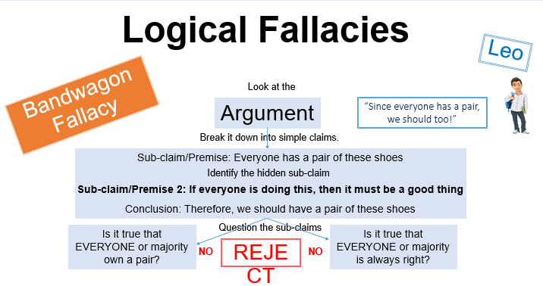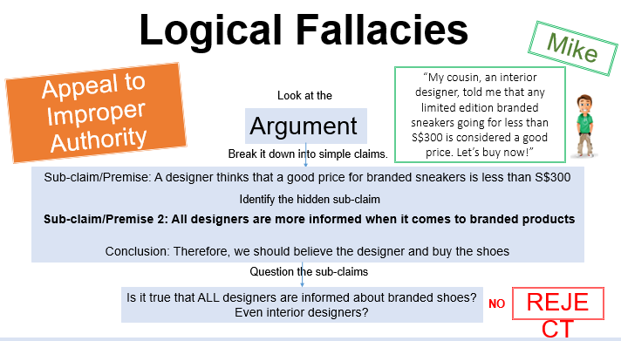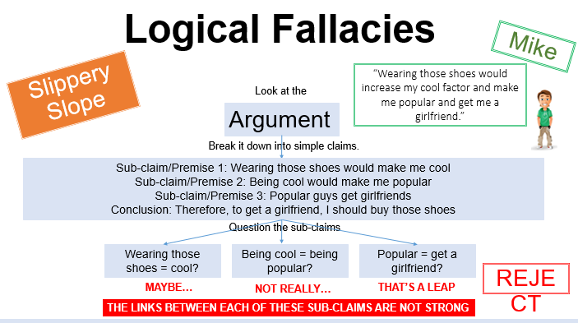

**Lesson 3**

Fake News - False information reported as if it were accurate & deliberately spread.

It hinders your ability to make informed decisions, potentially causing you to act on false information. Also, it creates confusion in society.

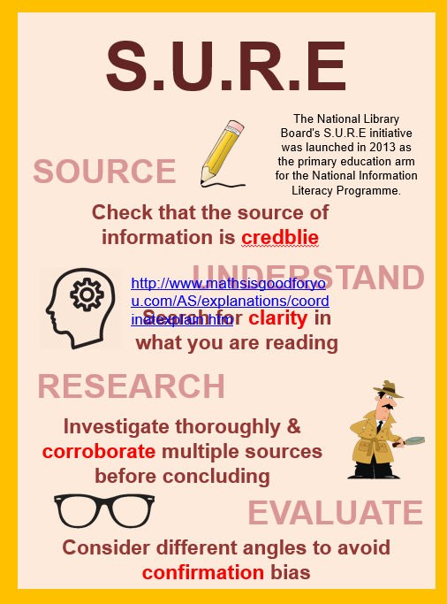

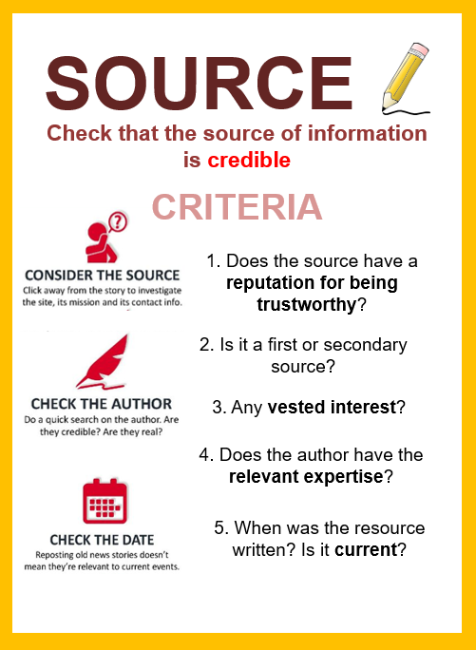

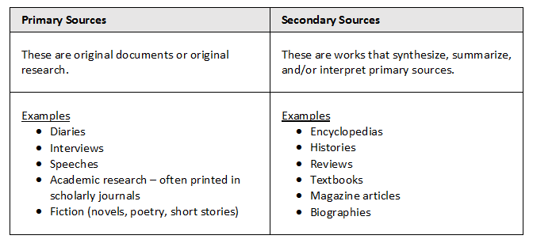

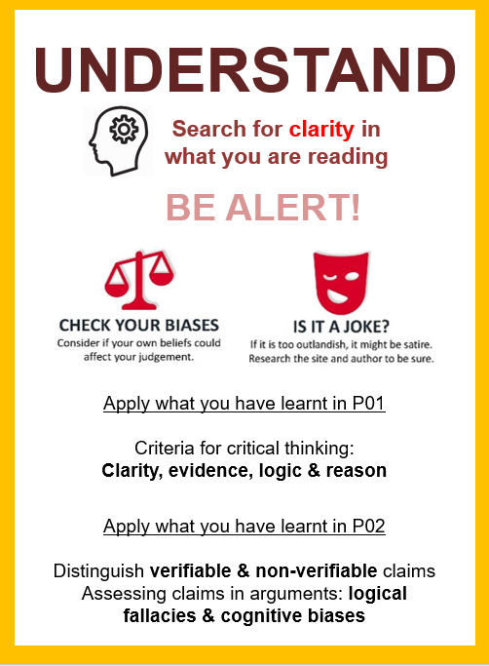 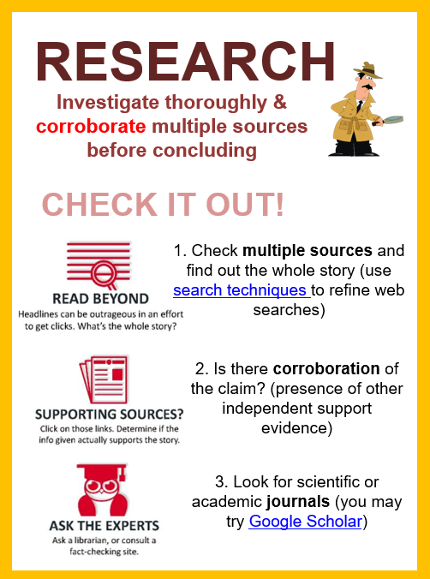 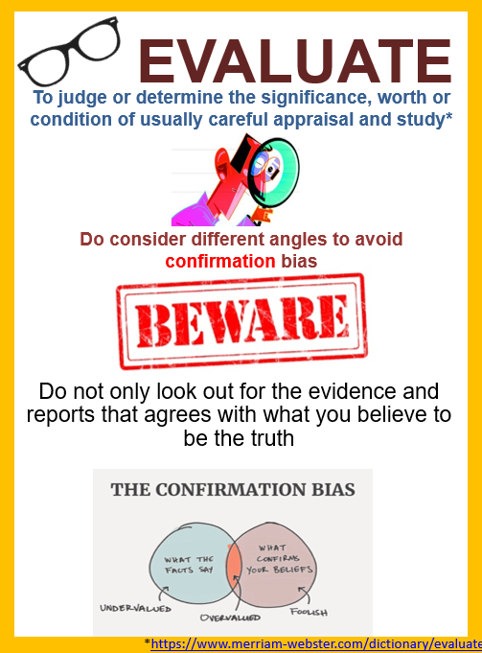

**Lesson 4**

Scientific Thinking

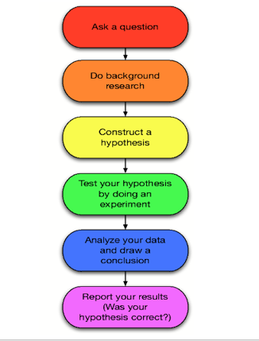

1. Ask a Question?
2. Do background research. Identify what you know.
3. Hypothesis

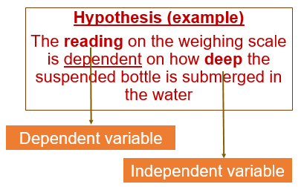

1. Conduct the experiment

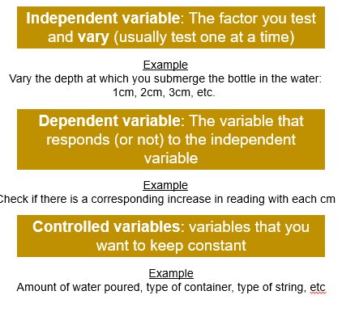

1. Analyse Date & Draw Conclusions

Example:

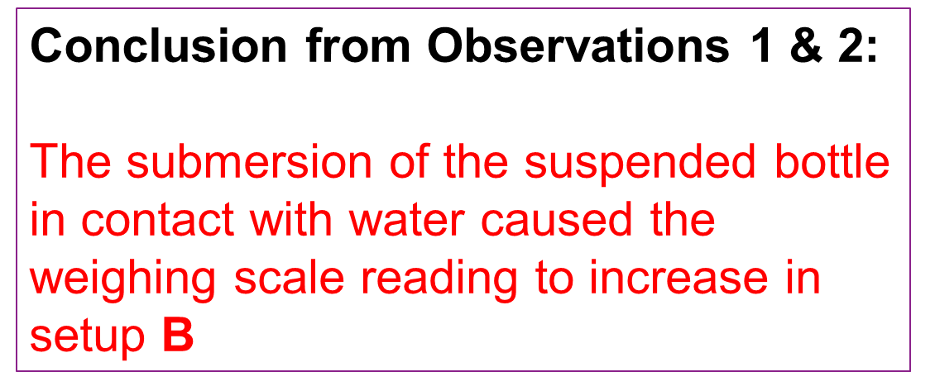

1. Report Findings

Example:

The reading on the weighing scale is determined by the height of the water level inside the container.

The content and the weight of the suspended bottle does not affect the weighing scale reading.

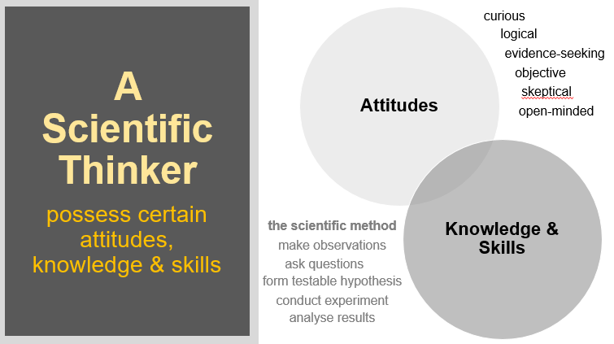

Lesson 5

Criteria to ensure investigation is scientific

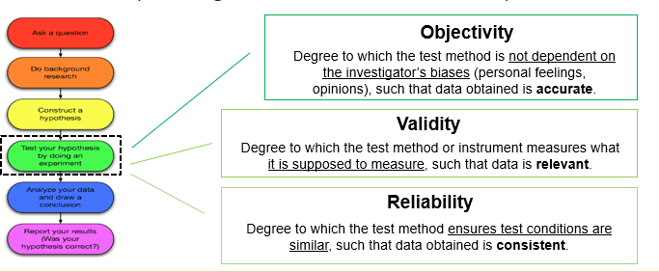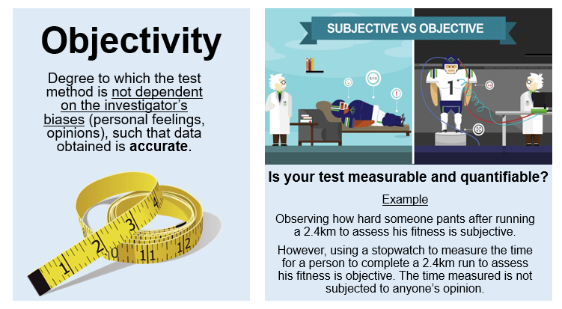 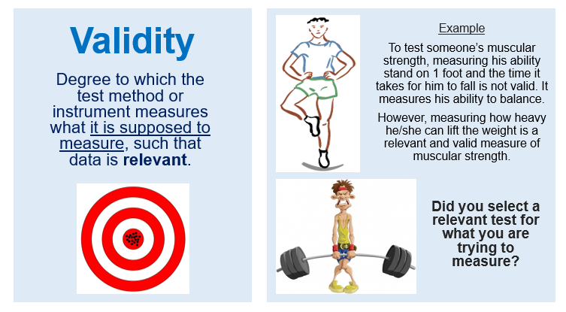 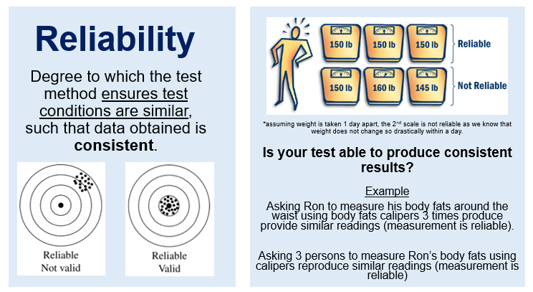

Sampling Methods

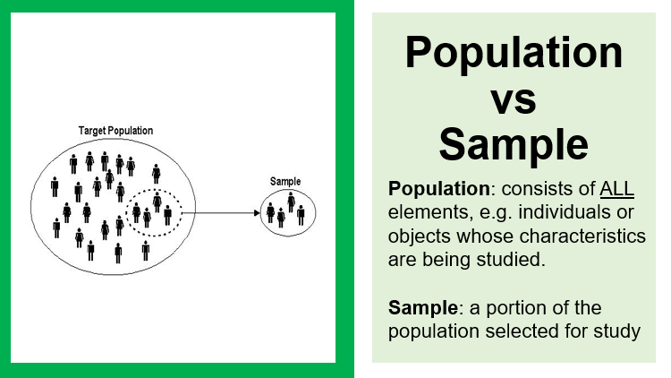 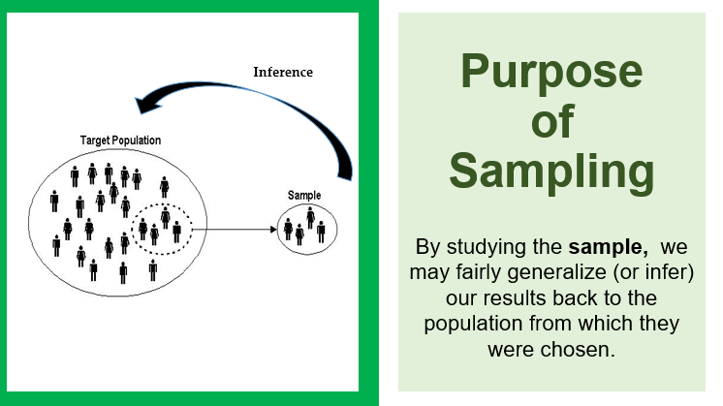 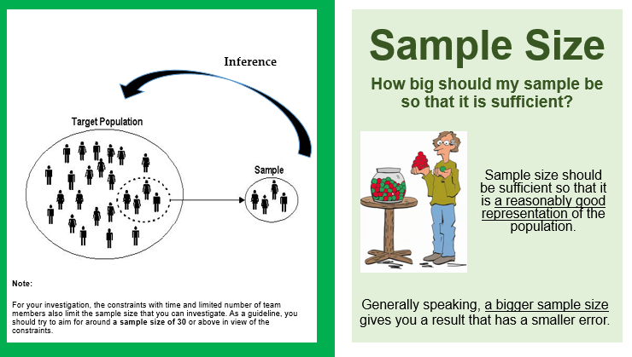

Lesson 6

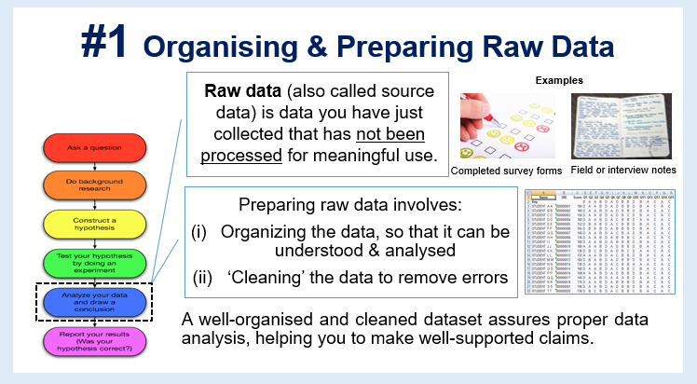 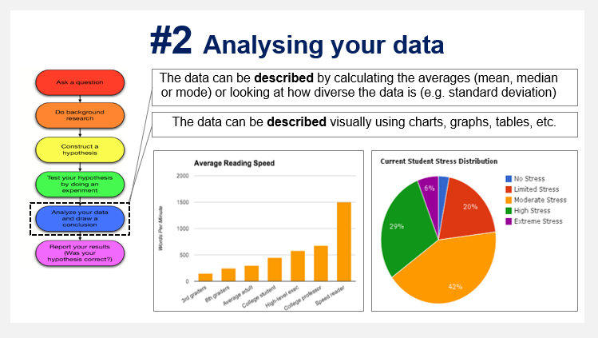 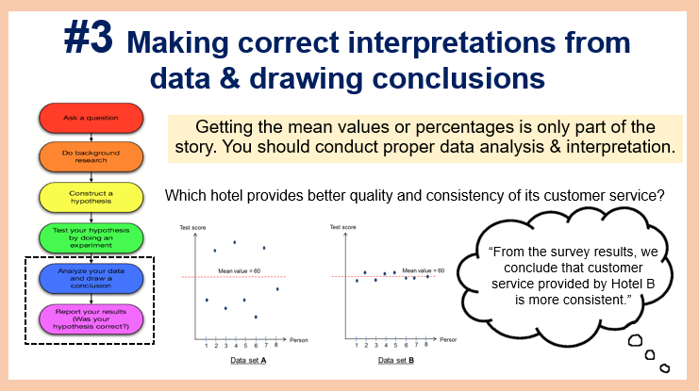 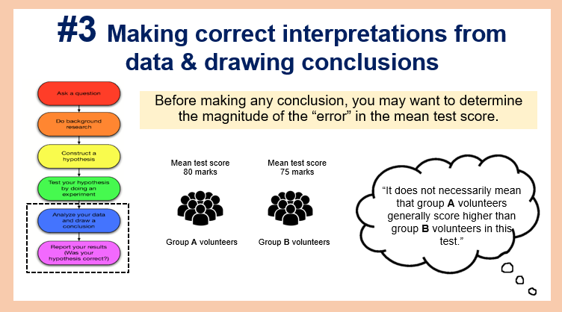 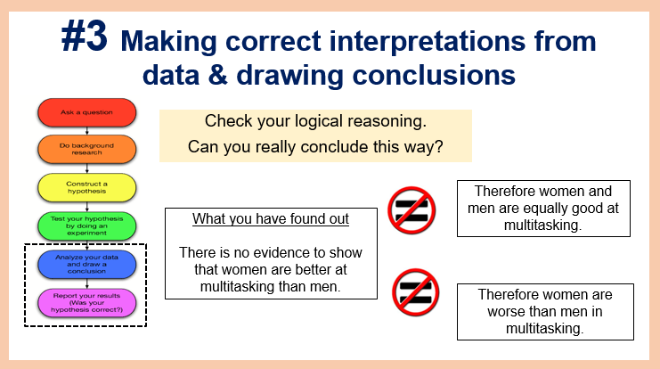 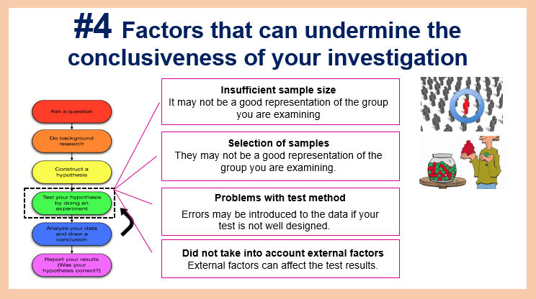

Lesson 8

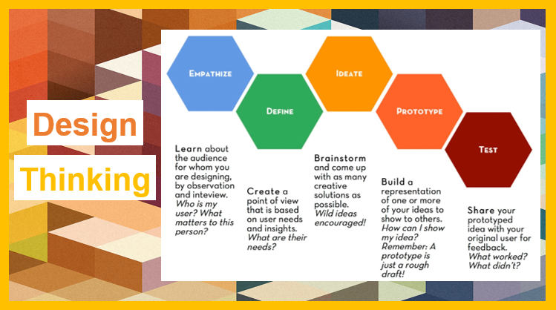



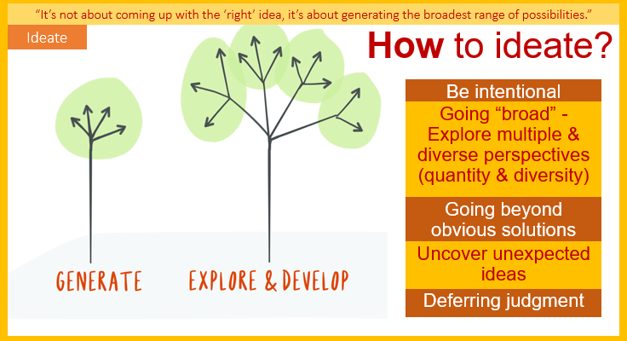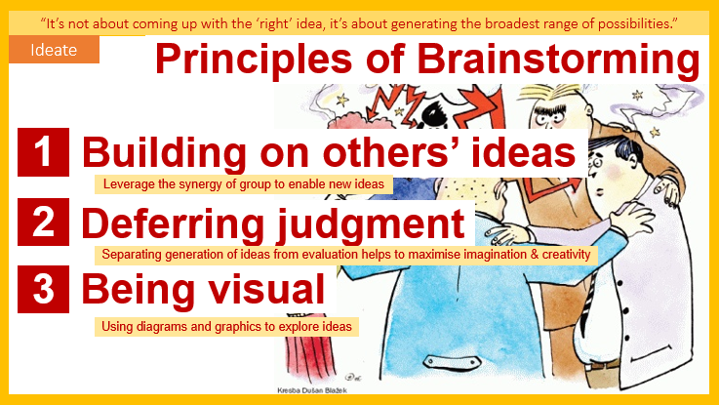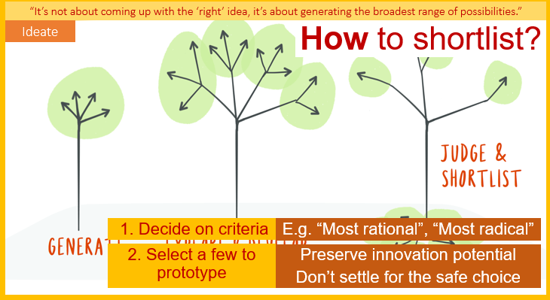

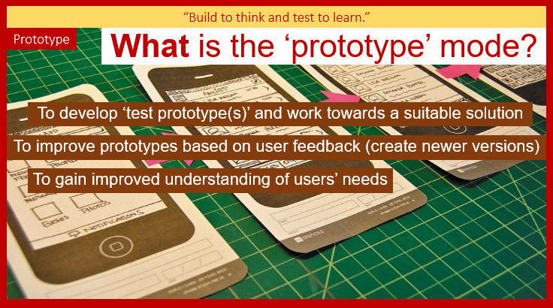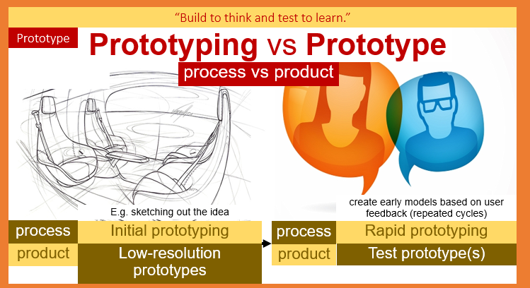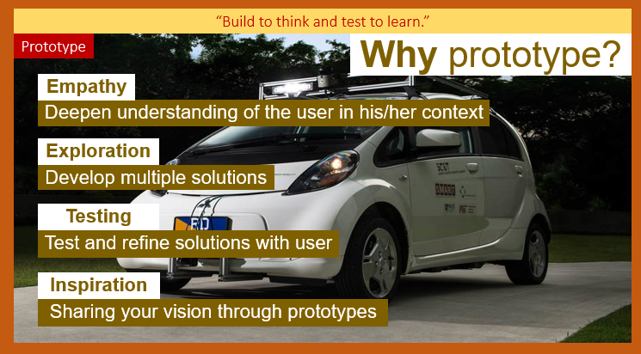

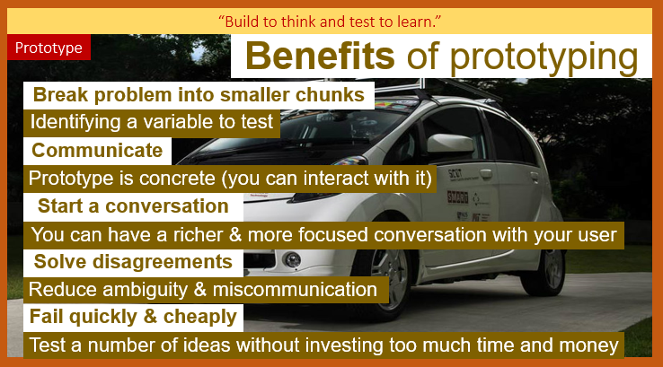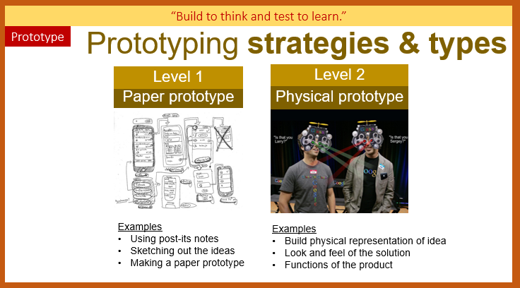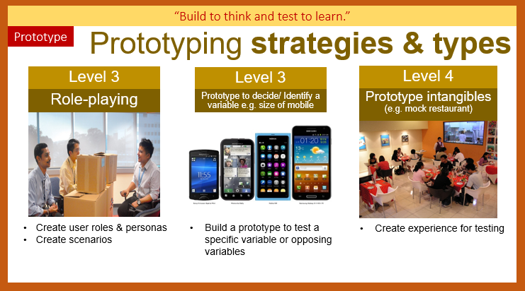

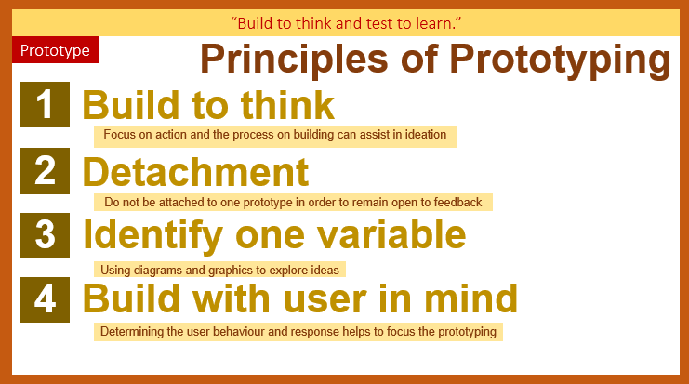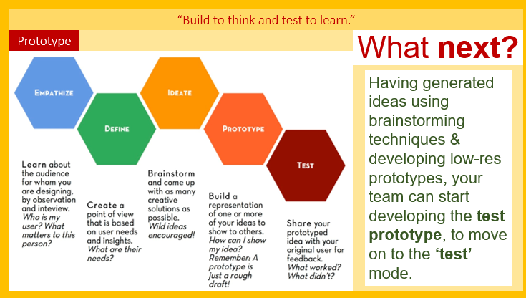

Lesson 10

